**Assignment 2**

**QNO1:**

**Code output Snip:**

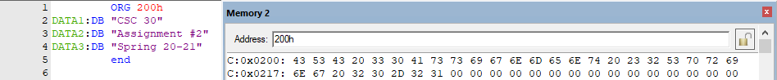

The above picture shows the contents of ROM starting from the location 200H.

**Question NO 2:**

**Code:**

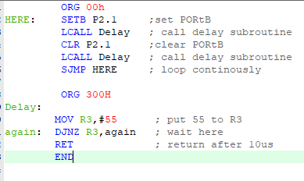

**Calculation for R3 for 10us.**

[(X x 2)+1+2] x 90ns = 10us

(2x + 3) x 90ns = 10us

(2x + 3) = 10us / 90ns

**X= 54**

So the value 54 will be placed in the R3 register.

**Logic Window:**

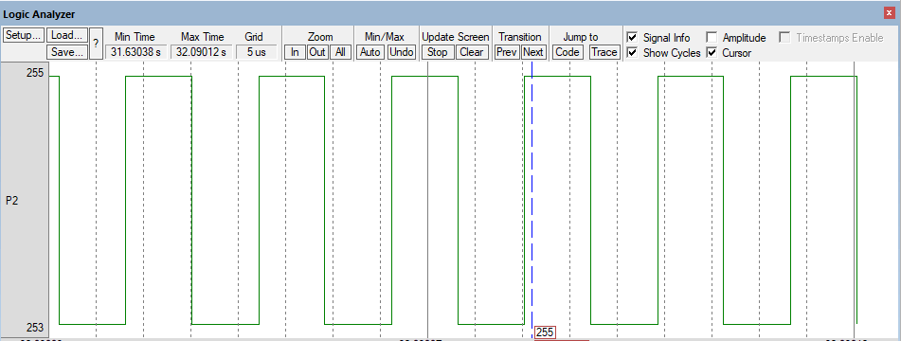

**Question NO 3:**

**Code:**

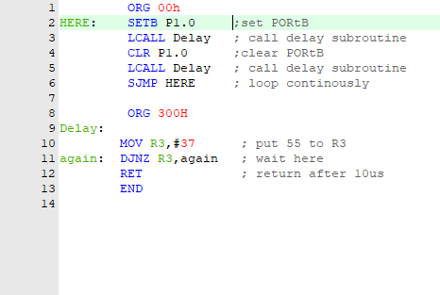

**Calculation for 70kHz for 10us.**

F= 1/T

T= 1/f

T= 1/70kHz

T= 14 ns

T= Ton + toff

S0 we will calculate delay for 7us

hence

[(X x 2)+1+2] x 90ns = 7us

(2x + 3) x 90ns = 7us

(2x + 3) = 7us / 90ns

**X= 37**

So the value 37 will be placed in the R3 register.

**Logic Window:**

